Pre-Interview questionnaire

**Please note:** We are looking for a wide variety of engineers. There is no question that will eliminate you from an interview, so please answer the following questions honestly. Furthermore, many questions are focused on simply understanding your personal preferences.

**Section 1: Generic qualifications and career orientation**

1. How would you describe your career preferences?
   1. I would prefer to do most of the work in my specific field of study. If so, which discipline?
   2. I simply enjoy problem solving and would prefer a position that allows me the chance to tackle a wide variety of problems.
   3. I would prefer a position that includes both problem solving, as well as communicating with internal and external engineers and project managers.
2. Which statement best describes you:
   1. I prefer to work on technical problems, typically on my own.
   2. I prefer to work on technical problems, within a small team.
   3. I prefer a more social work environment and like to work with others regularly.
   4. Not only do I prefer a social work environment, but I often find myself being a leader within a team.
3. How many years of embedded coding experience do you have?

I have 5 years of embedded coding experience.

1. Please tell us your experience in each of the following languages:
   1. Embedded C

PID Control: Implementation of a control system of DC motor in a microcontroller (DSP).

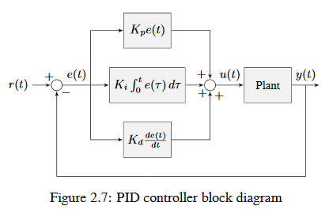

Real time data acquisition: Processing a continuous analog signal into discrete time digital samples for different sensors.

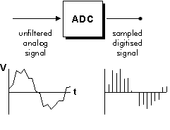

Communication Protocols: Implementation of different communication protocols: SPI, I2C, UART.

* 1. C++

RTOS: Data Logger for a group of scales.

MIMO Controller: Implementation of a controller with a MIMO plant.

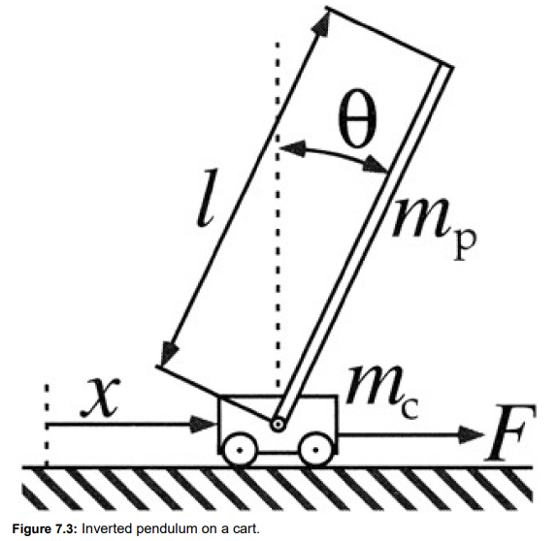

Real time data acquisition: Processing a continuous analog signal into discrete time digital samples for different sensors.

Communication Protocols: Implementation of different communication protocols: SPI, I2C, UART.

* 1. Python

Communication Protocols: Implementation of different communication protocols: SPI, I2C, UART, TCP/IP.

Data acquisition: Read different analog sensor and visualize its data.

Database Handling: Manipulation of the data, using SQL.

* 1. VHDL

Digital filters: implementation of FFT, FIR, IIR, LP, HP, BP, Notch and Wavelet.

Communication Protocols: Implementation of different communication protocols: SPI, I2C, UART, RS-485.

Digital Differential Analyzer (DDA): Plot the Lorenz ODE system using a digital differential analyzer and control the function of the circuit with the HPS.

1. Please rate your knowledge on the following (0: None to 5: Expert):
   1. Statistical
      1. Bayes’ theorem: 1
      2. Normal distribution: 3
      3. Independence of random variables: 0
   2. Tracking algorithms
      1. Kalman Filter: 1
      2. Extended Kalman Filter: 0
      3. Unscented Kalman Filter: 0
   3. Machine learning, regression, and classification
      1. Linear and logistic regression: 0
      2. Neural networks: 1
      3. Kernel methods: 0
      4. Principal components analysis: 0
   4. Data science
      1. Analysis or large data sets: 2
      2. Automation: 1
      3. Data visualization techniques: 3

**Section 2: Coding**

1. Please write a generic power function in C++:

int Power(unsigned int base, unsigned int exponent)

Example: Power(4, 3) = 4 * 4 * 4 = 64

int Power(unsigned int base, unsigned int exponente){

int sum = 1;

for(int i = 0; i < exponente; i++){

sum*= base;

}

return sum;

}

1. Name at least two uses of the “static” variable identifier in C++.

**Applications where previous state of function needs to be stored**: In a function, you can declare a variable as static, in this case, the static variable is allocated only once, and if the function is called multiple times, the value of variable in the previous call gets carried through the next function call.

**Static Variables can used to assign a unique id to all objects**: If a member variable is declared static, all objects of that class have access to a single instance of that variable, because the static variable don’t belong to a specific object; it belongs to the class.

1. Write the generic MIN macro in C++.

#define MIN(a,b) ((a) < (b) ? a : b)

1. What is the difference between a compiled language and an interpreted language?

A compiled language is where the program, once compiled, is expressed in the instructions of the target machine and machine code is undecipherable by humans.

An interpreted language isn’t compiled program into machine instructions, the instructions are not directly executed by the target machine, but instead read and executed by some other program

1. In linear algebra, what does it mean for a matrix to be singular? Can you give an example?

A singular matrix is a square matrix is said to be singular matrix if its determinant is zero i.e. |A|=0

$$A=\left[\begin{matrix}3 & 2 \\ 6 & 4\end{matrix}\right]$$

$$\left|A\right|=\left|\begin{matrix}3 & 2 \\ 6 & 4\end{matrix}\right|=\left(3*4\right)-\left(2*6\right)=0$$

**Section 3: Coding exercise**

1. **Given *n* non-negative integers representing an elevation map where the width of each bar is 1, compute how much water it can trap after raining.**

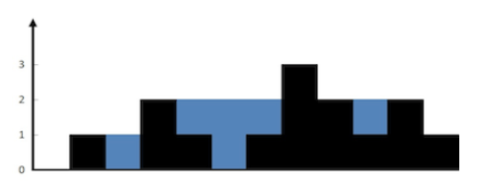

**For example, the above elevation map is represented by array [0, 1, 0, 2, 1, 0, 1, 3, 2, 1, 2, 1]. In this case, 6 units of rainwater (blue section) are being trapped.**

**#include <iostream>**

**using namespace std;**

**int water(int arr[], int arrSize)**

**{**

**int left[arrSize];**

**int right[arrSize];**

**int water = 0;**

**left[0] = arr[0];**

**for (int i = 1; i < arrSize; i++){**

**left[i] = max(left[i - 1], arr[i]);**

**cout<<left[i];}**

**cout<<endl;**

**right[arrSize - 1] = arr[arrSize - 1];**

**for (int i = arrSize - 2; i >= 0; i--){**

**right[i] = max(right[i + 1], arr[i]);**

**cout<<right[i];}**

**for (int i = 0; i < arrSize; i++)**

**water += min(left[i], right[i]) - arr[i];**

**return water;**

**}**

**int main()**

**{**

**int arr[] = {0, 1, 0, 2, 1, 0, 1, 3, 2, 1, 2, 1};**

**int arrSize = *(&arr + 1) - arr;**

**cout << "Water accumulated is "<< water(arr, arrSize)<<endl;**

**return 0;**

**}**